**APPENDIX X**

**Specific Sampling Protocols and Procedures for Chinook salmon escapement monitoring**

chinook salmon escapement Monitoring

Background

The total number of Chinook salmon (*Oncorhynchus tshawytscha*) that return from the ocean to streams in California’s Central Valley (CV) to spawn is termed ‘escapement.’ Beginning in 1953, mark-recapture carcass surveys were used to estimate Chinook salmon escapement in the lower Yuba River, although methods have varied. Historical annual reports list non-uniform sampling procedures including differing survey reach demarcations, varying survey duration and sampling areas. Different mark-recapture models were used for escapement estimation (i.e., Petersen, Jolly-Seber, and modified-Schaefer) over the years; however, the modified-Schaefer was most commonly used. Recent surveys (1994 and 1996-2010) were more consistent in both duration and area of survey, resulting in more comparable escapement estimates.

In 2003, CDFG installed Vaki Riverwatcher infrared systems (Vaki systems), produced by Vaki Aquaculture Systems Ltd., of Iceland, in the north and south fish ladders at Daguerre Point Dam (DPD) on the lower Yuba River to monitor fish passage. This tool provides a non-invasive method for gathering information on migrating fish year-round. The intent of using these sample devices was to estimate Chinook salmon escapement above DPD and potentially eliminate the need for the mark-recapture carcass survey. However, the Vaki systems experienced periods of non-operation during normal monitoring (operation ranged from 66-89% during the 2004-2008 sampling periods). The Vaki systems did not operate continually for multiple reasons including: power reliability, hardware reliability, flooding, high temperatures, and vandalism. Steps were taken to improve the reliability of the systems in 2010. The River Management Team of the lower Yuba River Accord (RMT) replaced the Vaki systems with the latest Riverwatcher technology that included high-resolution digital video cameras, underwater lighting, and new touch screen computers with increased data processing capabilities. In addition, precast buildings were installed above the ordinary high water mark with upgraded solar generation and storage capacity to address problems with power reliability, flooding, temperature and vandalism. The United States Fish and Wildlife Service (USFWS) Anadromous Fish Restoration Program funds were used to purchase the new solar panels and battery bank. All of these improvements not only greatly improved the operation of the systems, but the new technology produces better images to identify the species, sex, and adipose fin.

In 2011, the RMT developed this protocols and procedures to improve Chinook salmon escapement monitoring which will be used to meet goals of the lower Yuba River Accord’s Monitoring and Evaluation Plan (M&E Plan). The Vaki Riverwatcher systems have been proposed by the RMT to be the sole source of annual Chinook salmon escapement estimation upstream of DPD. In addition, recommended procedures are now available to estimate missed counts during the infrequent periods that the Vaki systems are inoperable with estimates of precision and bias (Bergman *et al.* 2011). A biological sampling survey is recommended to collect biological data (i.e., sex, fork length, scales, genetics, otoliths and female spawning status), recover coded-wire tags (CWTs), and other information (e.g., location collected) from Chinook salmon carcasses. The RMT recommends conducting a mark-recapture carcass survey for escapement estimates downstream of DPD using a superpopulation modification of the Cormack-Jolly-Seber (CJS) model. Mark-recapture carcass survey methods were reviewed in the development of a CV Adult Chinook Salmon Escapement Monitoring Plan and recommendations were made to use the CJS model to produce unbiased and precise estimates of escapement (Bergman *et al.* 2011). In the past, recapture rates of carcasses downstream of DPD were too low to estimate escapement using the modified-Schaefer model. Simulation modeling during the review found the CJS to produce reliable escapement estimates for population sizes as low as 250 fish (Bergman *et al.* 2011). In addition, the review found the modified-Schaefer model to be inappropriate for mark-recapture carcass surveys because assumptions of the model are violated and escapement estimates tended to exhibit an overestimation of population abundance in simulation modeling.

Goals of the escapement monitoring include: 1) use the genetic tissue samples collected during the carcass survey to differentiate spring-run and fall-run Chinook salmon;, 2) use the coded-wire tags to determine the origin of Chinook salmon (i.e., hatchery and river of origin);, 3) estimate the total, weekly, monthly and seasonal abundances of spring-run and fall-run Chinook salmon;, 4) estimate the abundance of natural- and hatchery-origin spring-run and fall-run adult Chinook salmon;, 5) utilization of length data to examine the size structure of the spring-run and fall-run Chinook salmon populations;, 6) utilization of scale samples to examine the age structure of the spring-run and fall-run Chinook salmon populations;, and 7) to examine multi-year trends in the annual run sizes of spring-run and fall-run Chinook salmon (i.e., total population, hatchery-origin and natural-origin).

This document describes the specific sampling protocols and procedures for conducting a biological sampling survey and implementing a mark-recapture carcass survey for the CJS model. Detailed specific sampling protocols and procedures for Vaki Riverwatcher monitoring are found in **Appendix F** of the M&E Plan.

1. **Survey Location**

The Yuba River watershed drains 1,339 mi2 along the western slope of the Sierra Nevada. The Yuba River’s confluence with the Feather River is located in Marysville, California. Between the mouth of the Yuba River and Englebright Dam, the first impassable barrier to anadromous fish migration on the Yuba River, there are approximately 24 mi of habitat potentially used by salmonids. Daguerre Point Dam is approximately 11.8 mi upstream from the mouth of the Yuba River and has two fish ladders (located on the north and south side of the river) to allow fish passage. Each ladder is outfitted with a Vaki system.

Vaki Riverwatcher Direct Estimation

The Vaki Riverwatcher systems at DPD will be utilized solely for escapement estimation for Chinook salmon from Englebright Dam to DPD. Annual sample data from the Vaki systems will be used to generate an estimate escapement. Missing counts due to system inoperability will be corrected using a General Additive Model.

Biological Sampling Survey

The survey area for biological sampling of carcasses is from Narrows Pool to just upstream of DPD (10 mi). The biological sampling survey will exclude the river reach from DPD to River Mile (RM) 11.5 for safety reasons associated with the dam.

Mark-Recapture Carcass Survey

The survey area for the mark-recapture carcass survey is from DPD to the Simpson Lane Bridge (10 mi), which includes all known Chinook salmon spawning habitat downstream of DPD.

1. **Survey Period**

Vaki Riverwatcher Direct Estimation

The survey period will being March 1 of the calendar year and end February 28.

Biological Sampling Survey

Field surveys must begin before any new carcasses have decomposed and unavailable for sampling. Field reconnaissance teams will begin to monitor Chinook salmon spawning in mid-August and will begin weekly surveys approximately 10-14 days after the first Chinook salmon redd is observed and will continue until no fresh carcasses are observed.

Mark-Recapture Carcass Survey

Field surveys must begin before any new carcasses have decomposed and unavailable for sampling. Field reconnaissance teams will begin to monitor Chinook salmon spawning in mid-August and will begin weekly surveys approximately 10-14 days after the first Chinook salmon redd is observed and will continue until no carcasses are observed.

1. **Sampling Frequency**

Vaki Riverwatcher Direct Estimation

The Vaki Riverwatcher direct estimation will be reduced to a weekly stratum.

Biological Sampling Survey

The biological sampling survey will be conducted weekly. All fresh carcasses will be sampled for biological data collection and CWT recovery. A fresh carcass is defined as having at least one clear eye (no milky color) and gills that are red or pink.

If the number of carcasses encountered during weekly sampling exceeds the capability of surveyors to complete collections during one day, a sub-sampling strategy will be employed in which every Nth fresh carcass observed will be sampled for biological data. This subsampling strategy must be chosen at the beginning of the survey week and maintained throughout the survey week. The Nth sampling frequency must be recorded in the PDA or on the datasheet, because carcass data collected downstream of DPD in the mark-recapture survey will need to be subsampled during analysis to obtain an unbiased sample from the population. Vaki Riverwatcher fish passage data or historic carcass survey data will be used to help establish the sampling frequency for Chinook salmon carcasses.

Mark-Recapture Carcass Survey

The mark-recapture carcass survey will be conducted weekly. All carcasses observed will be sampled.

1. **Sample Size**

Vaki Riverwatcher Direct Estimation

The sample size will include all Chinook salmon observed.

Biological Sampling Survey

All observed fresh carcasses will be subjected to biological sampling and CWT recovery. A fresh carcass is defined as having at least one clear eye (no milky color) and gills that are red or pink.

Mark-Recapture Carcass Survey

During mark-recapture carcass surveys, all observed carcasses (ad-clipped and non-clipped) should be subjected to tagging, biological sampling and CWT recovery unless the carcass will deteriorate upon handling, the presence of an adipose fin cannot be determined, or length and sex cannot be measured reliably. Carcasses that meet the requirements for tagging are termed ‘taggable’ carcasses. Carcasses that are not ‘taggable’ are termed ‘dead on capture’. Carcasses that are ‘dead on capture’ will be tallied and chopped.

1. **Monitoring Protocols and Procedures**
   1. Preseason Planning - Lead Biologist Responsibilities and Coordination Activities
2. The lead biologist will need to determine the sampling frequency based on their anticipation of run size (i.e., passage at DPD) and available resources (i.e., personnel, money, and equipment). The sampling frequency chosen must be maintained throughout a survey period.
3. The lead biologist will need to ensure the field crew is highly trained, logistics of the survey are organized, equipment is available and necessary permits and land access permissions are obtained.
   1. Data collection and Sampling Techniques

The weekly mark-recapture carcass survey and biological sampling survey will be conducted by a trained crew of 3-4 people and will be executed *via* motorized vessel and shoreline examination.

The following procedures describe the steps necessary to collect required data for estimating Chinook salmon escapement using the superpopulation modification of the CJS model in addition to collections of an unbiased carcass sample for biological data and CWT recovery.

* 1. Data Collection
     + 1. Biological sampling survey
  2. Record on each datasheet or in the PDA the general survey data
  3. Collect all observed carcasses using a gaff or spear pole
  4. Examine each carcass for a tag or mark
  5. Determine the freshness of the carcasses (i.e., fresh or non-fresh)
  6. If the carcass is non-fresh chop in half or release back into the river
  7. If the carcass is fresh collect biological data and recover CWT if ad-clipped
  8. Chop carcasses in half after sampling

Details for each of the seven steps are found below in sections 5.2.1.**2.1**, **2.2**, **2.3**, **2.4**, **2.7**, **2.8**, **2.9**, **2.10**, **2.11** and **2.12**.

* + - 1. Mark-recapture carcass survey
  1. Record on each datasheet or in the PDA the general survey data
  2. Collect all observed carcasses using a gaff or spear pole
  3. Examine the carcass for a tag or mark
  4. If the carcass is a recapture, record the disc tag number and return it to the river. If the carcass is decomposed to the point where you can’t determine the presence of an adipose fin, record the disc tag number and chop in half
  5. If the carcass is not a recapture, either mark the carcass with a disc tag or chop the carcass in half if not taggable.
  6. Collect biological data and recover CWTs
  7. Return tagged carcasses and chops into the river
     + - 1. General survey data

Record the following general survey data on the field datasheets or in the PDA:

* Survey date
* Time of arrival
* Initials of the samplers
* Initials of the data recorder
* Crew (1 or 2)
* Survey week
* Survey section
* Range of disc tag numbers allotted for use
* Weather
* Time of departure
* Secchi disk depth
* Mean flow
* Comments
  + - * 1. Collecting carcasses

The entire survey area must be examined for carcasses. Side channels will be walked to search for carcasses. Crew members should avoid using prior knowledge of carcass locations when searching to avoid biasing the sample.

Biological Sampling Survey

All observed carcasses that could be fresh should be collected using a gaff or spear pole. If the carcass is non-fresh upon closer inspection the carcasses can be removed the system (chopped) or put back into the river. All fresh carcasses collected need to be sampled for biological data and if ad-clipped, CWTs recovered.

Mark-Recapture Carcass Survey

All observed carcasses should be collected using a gaff or spear pole for examination.

* + - * 1. Determining freshness of a carcass

Fresh carcass: A fresh carcass has at least one clear eye (no milky color) and gills that are red or pink.

Non-fresh carcass: A decomposed carcass that has no clear eyes or no red or pink gills.

* + - * 1. Examine the carcass for a tag or mark

Inspect and roll the carcass using the gaff, look for disc tags in the lower jaw from the previous weeks’ surveys. In addition, examine the carcass for the presence of an adipose fin and floy/hallprint tag from hatchery marking practices and other scientific studies in the Central Valley. If a floy/hallprint tag is found, record the floy/hallprint tag number with the other data collected for that carcass.

* + - * 1. Recaptured carcass – release or chop

The mark-recapture population estimator (CJS model) requires the capture history of individual carcasses. If a carcass is a recapture, the following must be recorded: 1) disc tag number;, 2) if the carcass was released for multiple recaptures or removed from the system (chopped);, and 3) date that the carcass was recaptured.

All recaptured carcasses should be released for multiple recapture events. The CJS model will estimate the probability of survival and the probability of detection between recapture events (or lack of recapture); therefore, field crew members should understand this fact and not be concerned with the issue of the chances/likelihood of recapturing fresh versus non-fresh carcasses. ‘Freshness’ status is recorded for each individual and will be used in the CJS model when estimating escapement.

If a recaptured carcass exhibits a high level of decomposition where the presence of the adipose fin can no longer be determined, the crew will record the disc tag number and chop the carcass. In addition, the chopped recapture must be recorded as being removed from the system for the CJS model and date of removal.

* + - * 1. Unmarked carcass – tag or chop

A carcass is ‘taggable’ if it is not marked from a previous survey week, the presence of the adipose fin can be determined, and biological/covariate data (i.e., sex, fork length, ad-clip status) can be measured reliably.

All ‘taggable’ carcasses should be tagged in the lower jaw with a disc tag that has a unique identification number and survey date recorded (Figure 1). The mark-recapture population estimator (CJS model) requires individual carcass information. Therefore, all data must be recorded for each individual carcass. Sex, length and ‘freshness’ needs to be recorded for each ‘taggable’ carcass. The upper maxillary (snout) needs to be removed for ad-clipped carcasses for CWT recovery and the bottom jaw disc tagged.

If a carcass is not ‘taggable’, chop the carcass with a machete or other tool to remove from the system. This carcass will be considered ‘dead on capture’. Each chopped carcass needs to be tallied with the survey date for the CJS model.

*It is important to remember that a ‘taggable’ carcass can be fresh or non-fresh. A carcass ‘dead on capture’ will always be considered a non-fresh carcass.

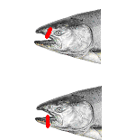

**Figure 1. Placement of a uniquely numbered disc tag for all ‘taggable’ Chinook salmon carcasses.**

* + - * 1. Collection of biological data and CWT recovery

Biological Sampling Survey

For each fresh carcass collected, the following biological data will be recorded: 1) sex;, 2) fork length;, 3) female egg retention status;, 4) scale sample identification number;, 5) head tag number (if CWT recovery is required);, and 6) river mile. Otoliths will be collected from all fresh carcasses when possible; otherwise a systematic sampling strategy will be used (see Section 5.3.1.2.12.3 for details). If a carcass is sampled for otoliths, the scale sample identification number will also be used as the otolith identification number, therefore identify on the PDA or data sheet if the carcass was sampled for otoliths and record the identification number on the coin envelope used to store otoliths.

Mark-Recapture Carcass Survey

For each ‘taggable’ carcass the following biological data will be recorded along with the disc tag number: 1) fresh or non-fresh;, 2) sex;, 3) fork length;, and 4) river mile.

For each fresh ‘taggable’ carcass include the additional information: 4) female spawning status;, 5) head tag number (if CWT recovery is required);, 6) scale sample identification number. Otoliths will be collected from all fresh carcasses when possible; otherwise a systematic sampling strategy will be used (see Section 5.3.1.2.12.3 for details). If a carcass is sampled for otoliths, the scale sample identification number will also be used as the otolith identification number, therefore identify on the PDA or datasheet if the carcass was sampled for otoliths and record the identification number on the coin envelope used to the store otoliths.

* + - * 1. Sex determination

Male carcasses typically have a longer hooked jaw, large canine teeth, and a less rounded body than females (Figure 2). In addition, they are typically larger than females and can have red coloration.

Female carcasses typically have a symmetrical upper and lower jaws, may appear more plump or rounded than males, will often have eroded tails and vents from recent redd construction and egg deposition (Figure 2).

If the sex of the carcass is not apparent, the ventral side of the carcass can be rubbed to see if eggs or milt are released from the body cavity.



**Figure 2. Male (top), Female (middle), and Grilse (bottom) Chinook salmon carcasses.**

* + - * 1. Length measurement

Fork length (cm) refers to the length from the tip of the snout to fork of the caudal fin.

* + - * 1. Determining egg retention for female salmon

Visually examine all fresh female Chinook salmon carcasses for egg retention. Characterize the fresh female Chinook salmon carcasses as spawned or unspawned. An unspawned female will be easily recognized as gravid and will often eject eggs from vent when lifted. A spawned female can be characterized as appearing emaciated, the visceral cavity will seem evacuated, and will exhibit folds of skin on the ventral side.

* + - * 1. Adipose fin clip status and CWT recovery

Biological Sampling Survey

All fresh carcasses that are missing an adipose fin (ad-clipped) will be identified as having a CWT, and the head will be removed for CWT recovery (Figure 3). Record required data on a head tag provided by CDFG and in the PDA or field datasheet. Attach the tag to the head for identification. Place the tagged head in a Ziploc bag for storage.





**Figure 3. Chinook salmon with adipose fin missing (top) and the location to remove the head (black line), and a Chinook salmon with an adipose fin (bottom).**

Upon returning to the field office place heads into a chest freezer for storage. A chain of custody form will be filled out to track possession of the heads. The chain of custody will include information such as head number, sample location, dates and time of collection, and name of person who collected the sample. For each change of possession, the person relinquishing the sample and the person receiving it must sign and date/time the chain of custody form.

Mark-Recapture Carcass Survey

All fresh carcasses that are missing an adipose fin (ad-clipped) will be identified as having a CWT. Remove only the upper maxillary for CWT recovery using a serrated knife, as the lower jaw will be marked with a disc tag **(**Figure 4**)**. Record required data on a head tag provided by CDFG for identification and in the PDA or field datasheet. Place the upper maxillary and head tag in a Ziploc bag for storage.

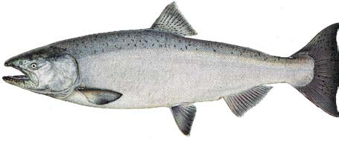



**Figure 4. Chinook salmon with adipose fin missing (top) and the location to remove the upper head (black line), and a Chinook salmon with an adipose fin (bottom).**

Upon returning from the field, office place heads into a chest freezer until for storage. A chain of custody form will be filled out to track possession of the heads. The chain of custody will include information such as head number, sample location, dates and time of collection, and name of person who collected the head(s). For each change possession, the person relinquishing the sample and the person receiving it must sign and date/time the chain of custody form.

* + - * 1. Collecting tissue samples

Genetic tissue samples

Refer to **Appendix E** (Specific Sampling Protocols and Procedures for Genetic Sampling). The scale sample identification number (described below; Section 5.2.1.2.12.2) will be used to identify the genetics sample for the carcass. Record the ID number of on the coin envelope used to store the genetics sample and identify on the datasheet or in the PDA that a genetic tissue sample was taken.

Scale samples

All observed fresh Chinook salmon carcasses will have scale samples and associated data collected. For the CDFG Age Scale Program, a minimum goal of 550 scale samples is preferred for each run of Chinook salmon being sampled (Kormos 2007).

Scale samples will be collected from a key scale area, located on the left side of the fish, diagonally down from the posterior insertion of the dorsal fin and just slightly above the lateral line (Figure 5). Consistency in collecting scales is important because the growth rates of scales differ on different parts of a fish’s body, which can influence the analysis of the scale pattern (Bugaev 2004).



**Figure 5. Key scale area of Chinook salmon carcass for collecting scale samples (Kormos 2007)**

Scale sample procedure (Kormos 2007):

1. For fresh Chinook salmon carcasses, lay the carcass on the boat or ground with their left side facing up. Record the following information of the datasheet (Attachment 1) and scale envelope:

❑ Date (i.e., mm-dd-yy)

❑ Location (i.e., river mile)

❑ Total length (i.e., nearest mm, if tail eroded then to nearest ½ cm and round up)

❑ Sex (i.e., male or female)

❑ Adipose-fin clip status (i.e., present, absent or unknown)

❑ Headtag number (i.e., adipose fin-clipped carcasses)

1. Locate the key area on the left side of the fish’s body (Figure 5). If scales cannot be collected from this area, use the right side; if scale sampled cannot be taken from the desired area on the right side, then gather scales from up to two inches outside the key area but above the lateral line.
2. Wipe the sample site clean of mucus and dirt with a fillet knife. Remove a 3-4 cm square patch of skin from the key area by thinly slicing away the skin patch from the fish with the fillet knife. Be careful to eliminate as much muscle and fat as possible while removing the skin patch (quality of the sample is better during processing).
3. Slide off the skin patch from the knife blade between wax paper inside the scale envelope, with the skin patch laying flat in the envelope.
4. Record the unique ID number of the scale envelope on the datasheet (Attachment 1). Scale envelopes are preprinted from CDFG Age Scale Program.
5. Thoroughly clean all scale sampling equipment, make sure all scales are removed from the equipment before sampling the next carcass.
6. Keep all scale sample envelopes organized and stored together. Scale sample envelopes should be stored in a dry location with adequate ventilation (e.g., bucket, plastic bag, back-pack, etc.).

Drying the scale samples is an important part of the sampling process and can affect the quality and usefulness of the samples. Immediately after collecting all of the scale samples, dry the samples for preservation and for prevention of rotting or deterioration. In the office, dry the samples by placing the scale samples on a clean dry surface in a well ventilated area that is kept at ~70 F. Lay the samples out individually without any overlapping or stacking of the envelopes. Air drying the samples will take 24-48 hours (depending on the size of the sample and environmental conditions).

Once scales are dry, data can be entered into the database and scale envelopes can be stored in a box for eventual processing. Scale sample envelops should be organized numerically and temporally to ease processing. Scale samples will be provided to the Central Valley Scale Aging Program for reading.

Otolith samples

In the field, an attempt will be made to remove otoliths from all fresh Chinook salmon carcasses. If all fresh carcasses cannot be sampled, personnel will sub-sample for otoliths during the survey period by systematically sampling every Nth fresh Chinook salmon carcass. Personnel will determine the Nth sampling interval at the beginning of each survey week, record the sampling interval in the PDA or on the field datasheet in the comments section, and maintain that interval for the survey week.

For the mark-recapture survey, the lower maxillary must remain intact for tagging with a disc tag. A high quality serrated knife or bread knife is needed to make clean cuts. Otoliths can be stored in vials or coin envelopes. Wearing cotton or neoprene gloves helps hold the carcass while making the cuts. Each otolith sample must have a unique identification number to relate the otolith information to other data collected for that fish, that unique number will be the same as the scale identification number printed on the envelope used to store scales collected from that carcass. Either of the following two methods will be used to remove otoliths:

One quick and efficient method to remove otoliths is called the “open hatch’ or“flip top” approach described below (Scarnecchia 1987):

1. Make the first cut vertically starting on the top of a fish between the eyes and the extension of the gill cover, and end above the extension of the eye (Figure 6; photo 1)
2. Make a second cut horizontally starting at between the eyes and the nose on the anterior of salmon and toward the first cut
3. The cranial cavity will be exposed when two cuts meet with each other (Figure 6, photo 2)
4. Extract otoliths using forceps and place the otoliths in uniquely labeled vials or coin envelopes.
5. Record the vial or coin envelope number on the datasheet.

A second method is simply cutting the head down the middle perpendicular to the tip of the snout (Figure 7). The head can be split open and the otoliths can be found in the brain cavity. Depending on the cut, otoliths can be located in one side of the head or one otolith can be located in each side of the head. The bottom jaw remains intact for tagging.

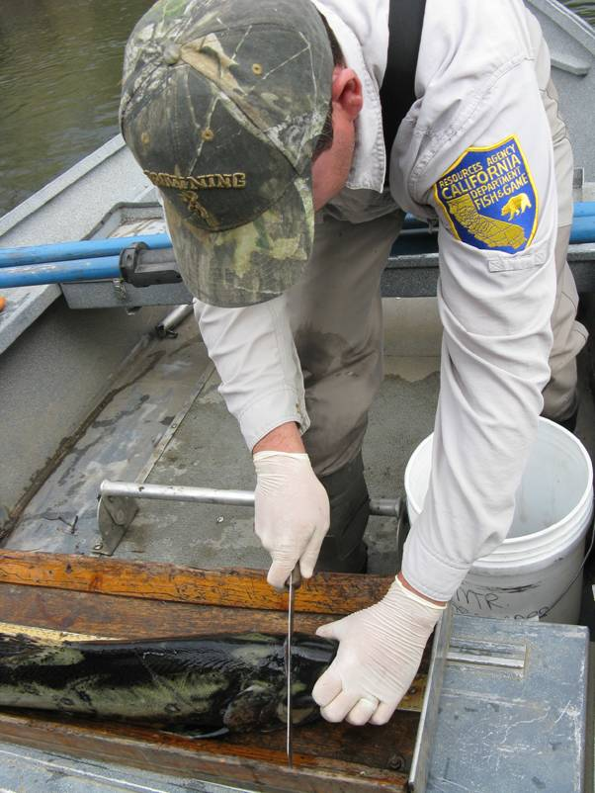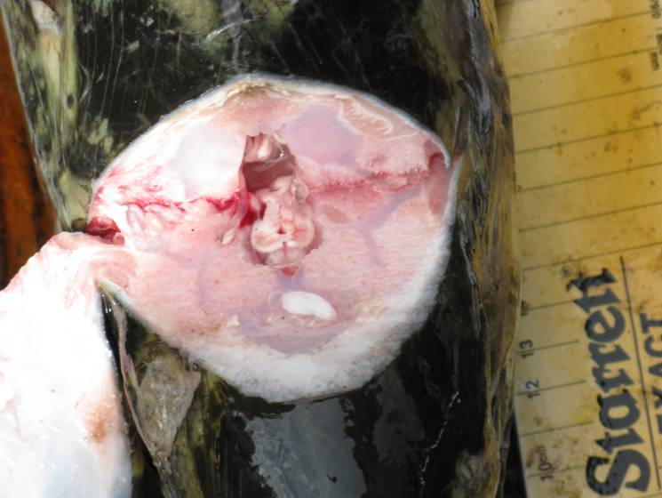

**Photo 1 Photo 2**

Figure 6. The “open hatch” approached used to extract otoliths from a Chinook salmon carcass. (Photo Credit: Tim Heyne, CDFG, 2011).

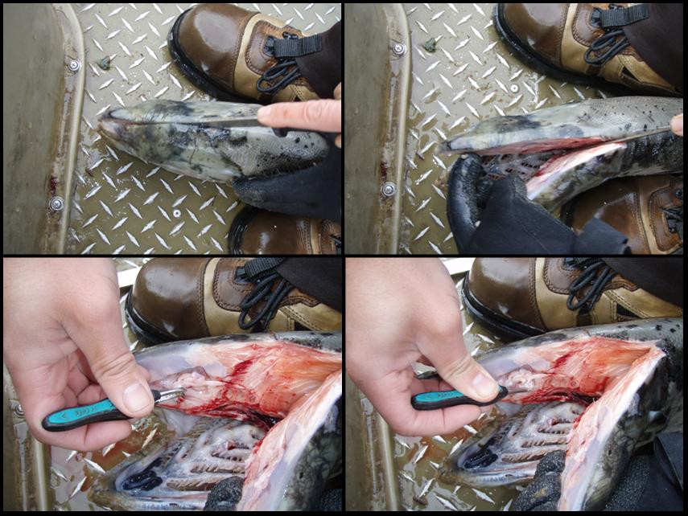

Figure 7. The process of removing otoliths from a Chinook salmon carcass with an intact adipose fin. Otoliths are removed by cutting down the center of the head perpendicular to the snout and taking otoliths from the brain cavity. The bottom jaw is left intact for tagging. If the carcass was adipose fin-clipped, the upper head would be removed leaving the bottom jaw for tagging. The head and pieces cut would be placed in a bag with a head tag for coded-wire tag recovery. (Photo credit: Leslie Alber, PSMFC, 2010)

* 1. Quality Assurance/Quality Control Processes

To facilitate accurate data collection in the field, each surveyor will be in continuous radio contact with crew leads. All data will be relayed directly to crew leads for data recording. Raw field datasheets or PDA will undergo an initial QA/QC in the field. Carcass survey data entered or uploaded into the database will be subjected to additional QA/QC for consistency and error elimination.

1. **Logistics**
   1. Personnel

Escapement survey personnel will be responsible for conducting the biological sampling survey and mark-recapture carcass survey. This entails data collection and data management described in this protocols and procedures. In the field, experienced survey staff will train newly hired survey staff in survey techniques.

* 1. Qualifications

To successfully complete the escapement survey protocols and procedures, lead staff conducting the work will have the following minimum requirements: 1) related 4-year college degree (e.g., fisheries biology or biology);, and 2) minimum of 2 years of professional experience in fisheries field surveys.

The data collection methods will be conducted by 3-4 person monitoring teams to facilitate safe and efficient data collection. When monitoring is being conducted, at least one team member will have the minimum qualifications as stated above.

* 1. Training

This protocols and procedures will be made available to all escapement monitoring personnel to promote consistency among data collection and to address safety concerns. New hires will be scheduled to conduct surveys with experienced carcass survey staff and receive training in the office and in the field. Crew members will be trained on the escapement monitoring protocols and procedures by reading and becoming familiar with each component of data collection and management. Safety, aspects of landowner relations, trespassing regulations, and escapement monitoring protocols and procedures training will be scheduled and conducted prior to initiating the field season for all survey crew members. Safety training for field crews should include first aid, wilderness medicine, swift water rescue training, boat safety, and wader safety training. Specialized training for operating all-terrain vehicles, four-wheel drive vehicles, boats, or other equipment needed for conducting the carcass surveys will occur during the pre-field season period.

* 1. Schedule

The timing of conducting the surveys is important for collecting, managing, and analyzing the data and for writing the annual report. The following is a schedule outline for preparatory efforts, for collecting, managing, and analyzing data and for synthesis of an annual report.

**Pre-Season**

* Conduct pre-season preparation and planning (i.e., hire field crews, coordinate logistics, scheduling and costs with laboratories that will be conducting genetics and scale analyses, test equipment)
* RMT Planning Group coordination
* Conduct Field Crew Technical Training
* Conduct Field Crew Safety Training

**Late-August through September**

* Conduct Initial Redd Reconnaissance Surveys
* Initiate Carcass Surveys (i.e., conduct this protocols and procedures)

**October through January**

* Complete Carcass Surveys (i.e., conduct this protocols and procedures)

**January through May**

* Finalize Data QA/QC and Compilation
* Data Analysis
* Prepare Draft Annual Carcass Survey Report
* RMT Planning Group Review of Draft Annual Escapement Survey Report
* Prepare Final Annual Carcass Survey Report
  1. Costs



* 1. Equipment List

|  |  |
| --- | --- |
|  | |
| • Motorized Vessel | • Disc Tags |
| • Trimble Geoexplorer GPS unit, with data dictionary loaded | • Thermometer |
| • Chest Waders or Wading Boots | • PDA |
| • Filet Knives | • Pliers |
| • Data sheet | • Machetes |
| • Scale Envelopes | • Gaffs |
| • Survey Protocol | • Genetics Envelopes |
| • Clipboards | • Aerial Photographs |
| • Pens, Pencils, Sharpies (permanent marker) | • CDFG Head Tags |
| • Hach 2100P Turbiditimeter | • Polarized Sunglasses |
| • Brimmed Hat | • Watch |
| • Dry Cloth (to dry off equipment, etc.) | • Swift Water Safety Gear |
| • Cellular or satellite phone | • First Aid Kit |
| • Backpack or surveyor’s vest | • Lifejackets/Other Personal |
| • Contact and emergency phone numbers | • Digital Camera |
| • Extra Batteries | • Rain Gear |
| • Food and Water | • Sun Screen |
| • Serated Knives | • Forceps (fine point) |
| • Neoprene Gloves | • Ziploc Freezer Bags |
|  |  |

1. **Data Management**
   1. Data Entry and Data Processing

A relational Microsoft Access (Access) database will be used to manage all raw field data. Pendragon software will be used to maintain the database application for recording field data in a PDA. This application is compatible with Microsoft Access. In addition, error checking is incorporated into the application to prevent missing required data collection. Crew members will use the PDA for data recording in the field and carry back-up paper field datasheets in the event the PDA malfunctions. Crew members will be in radio contact with crew leads via two-way radio. Crew members are required to relay all data for each carcass observed to the crew lead or data recorder. The Crew lead is responsible for making sure data is being recorded correctly and no data are missing.

* 1. Data Storage and Archival Procedures

All raw or primary field data will be organized, in an electronic format (Access Database), and archived in two locations. Reports will be prepared annually and archived. Data sets and reports will be submitted to the RMT.

Electronic files and print copies of the field datasheets will be located at:

Yuba County Water Agency Yuba Accord RMT Field Office

1220 F Street 4413 Highway 20

Marysville, CA 95901-4226 Marysville, CA 95901

Data Retrieval Contact: Project Manager – Duane Massa

Telephone Number: (530) 570-3474

Email Address: duane@psmfc.org

**REFERENCES**

Bergman, J., R, Nielson, and A. Low. 2011. California Central Valley Chinook salmon escapement monitoring plan Draft. California Department of Fish and Game. Sacramento, CA.

Bugaev A.V. 2004. Scale pattern analysis estimates of the age and stock composition of Chinook salmon Oncorhynchus tshawytscha in R/V TINRO trawl catches in the western Bering Sea in September-October 2002 (NPAFC Doc. 764) 15 p. KamchatNIRO, Kamchatka Fisheries & Oceanography Inst., Fisheries State Commit. of Russia, Naberezhnaja Street 18, Petropavlovsk-Kamchatski, Russia.

California Department of Fish and Game (CDFG). 2008. Field gear decontamination protocol

for New Zealand Mudsnails (Potamopyrgus antipodarum) Draft. CDFG, North Central Region.

Kormos, B. 2007. Escapement survey sampling: scale aging field sampling standard operations and procedures. Version 1.0. California Department of Fish and Game, Central Valley Age Scale Program (unpublished).

Scarnecchia, D. L. 1987. Rapid removal of otoliths from salmonids. North American Journal of Fisheries Management 7:312-313.